**Class: TE AIML Academic Year: 2024-2025**

**Name: Rutuparna Kolte**

**Roll no. : 122A9042**

**Experiment – 8**

**Design a network using three routers and configuring their routing tables for dynamic routing**

**_______________________________________________________________**

1. **Aim**: To design a network using three routers and configuring their routing tables for dynamic routing.
2. **Objective:**
3. Studying and implementing dynamic routing.
4. Connecting different networks using routers, configuring the interfaces and routing tables of the routers to perform dynamic routing.

**3. Requirements:** The following are the requirements **–**

* PC/Laptop
* Cisco Packet Tracer
* Browser

**4. Pre-Experiment Theory:**

Routing Information Protocol (RIP) is a dynamic routing protocol that uses hop count as a routing metric to find the best path between the source and the destination network.

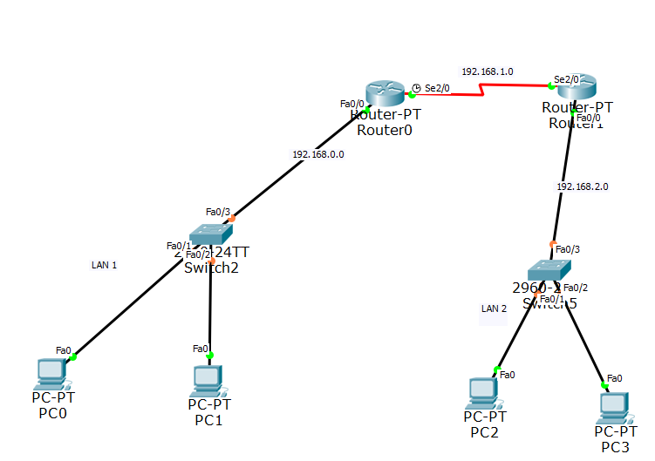

**5. Laboratory Exercise:**

**A. Procedure**

**Design following network scenario:**

1. Start packet tracer and design the network as given in Figure 1.
2. Configure the router and end devices as described in section below.
3. Test the configuration by sending simple PDUs.

**Details of Router Configuration:**

1. Reboot Router by powering it off and on under the physical tab.
2. Router performs the Power ON Self-Test (POST).
3. Click on ‘Config’ tab and then choose one of the interfaces for configuration. Provide appropriate IP address and subnet mask.
4. Proceed similarly for all other interfaces in use.
5. To update the routing table of Router follow these steps,
6. Identify magnifying glass icon available at the vertical right pane of the packet tracer. Click the magnifying glass on to Router and select the routing table from the drop down list. A routing table for Router will be displayed having 2 entries typed as C (connected) with next hop field blank.
7. The routing table is to be updated with the next hop entry, so that the Simple PDU could be send on to the other network. Provide addresses of the networks you want the router should be able to connect to. This can be done from routing ‘RIP’ option in ‘Config’ tab.
8. Configure all the end devices by providing them IP address, subnet mask and the default gateway address.
9. Test your network by sending simple PDU’s or pinging the computers from one network to other network.

Take screenshots for the network scenario showing successful pakcet transmission from one network to other and attach as the output. Explain the screenshots in detail.

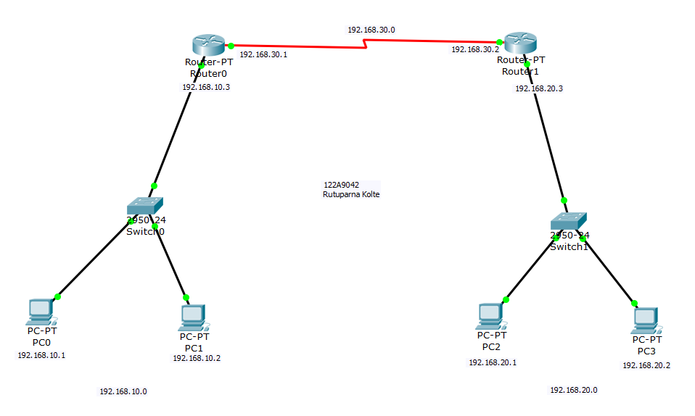



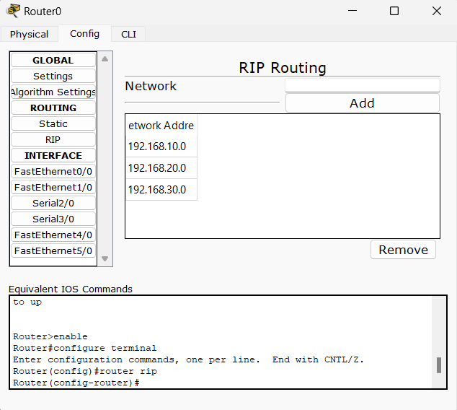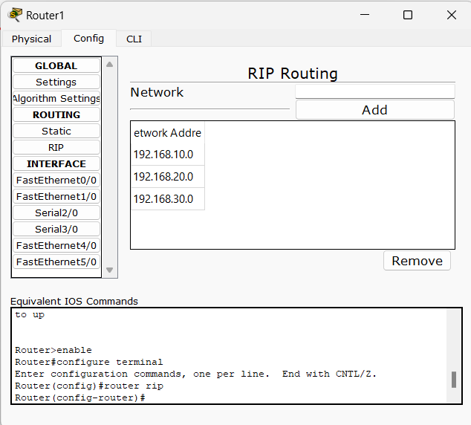

1. **Conclusion:**

In this experiment the routers interfaces and routing tables are configured to perform dynamic routing and checked that simple PDU’s are transmitted from one network to another through routers. Thus we learned to design a simple network with routers using dynamic routing.